
Name: Abdul Samad
Program: BSSE Group A
Semester: 5th
Date: September 16, 2026
Lab Task 2 - Report
*---------------------------------------------* Scenario: Online Food Delivery System

Problem Statement
Customers browse restaurants and place orders. Restaurants receive orders and update order status. Delivery riders receive delivery requests and update delivery status. A payment service processes online payments. An administrator manages users, restaurants, and complaints.

Extracted Requirements
- R1: Customers must be able to browse restaurants/menus and place orders.
- R2: Customers must be able to pay for orders online.
- R3: Restaurants must be able to receive orders and update order status.
- R4: Delivery riders must be able to receive delivery requests and update delivery status.
- R5: The system must communicate with a payment service to process payments.
- R6: An administrator must be able to manage users, restaurants, and complaints.

Identify External Entities
The following entities are outside the boundary of the Online Food Delivery System but interact with it:
External Entity | Why External? | Major Interaction
Customer | A person using the system, not an internal software component. | Requests restaurant/menu information, places orders, makes payments, receives order status.
Restaurant | An independent business external to the software system. | Receives new orders; sends order status updates.
Delivery Rider | A person outside the software system who fulfils deliveries. | Receives delivery requests; sends delivery status updates.
Payment Service | A separate external paymentprocessing service. | Receives payment requests; sends payment confirmation.
Administrator | A person managing the platform, not an internal component. | Manages users, restaurants, and complaints.

Identify Major Information Flow

External Entity | Information Sent to System | Information Received | Related  Requirements
Customer | Browse request, order placement request, payment info | Restaurant/menu list, order confirmation, order status updates | R1, R2
Restaurant | Order status update | New order details | R3
Delivery Rider | Delivery status update | Delivery request | R4
Payment Service | Payment confirmation | Payment request | R5
Administrator | Manage users / restaurants / complaints | Management confirmation / records | R6

Context Diagram
The context diagram below treats the entire Online Food Delivery System as one unit. Customer, Restaurant, Delivery Rider, Payment Service, and Administrator remain outside the system boundary. Internal modules are intentionally not shown here.
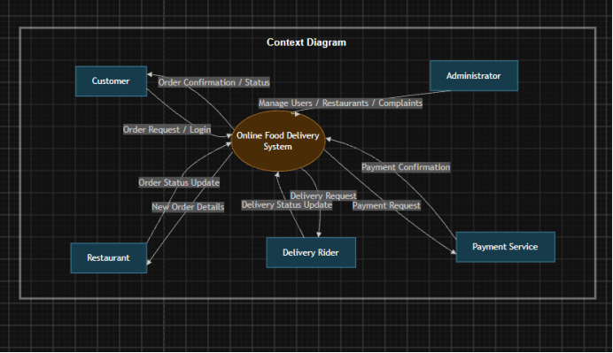

Explanation
- The central node represents the complete software system.
- Customer, Restaurant, Delivery Rider, Payment Service, and Administrator are external entities.
- Flows are labeled with meaningful information (e.g., "Order Request / Login") rather than generic terms such as "data".
- The diagram does not show databases, screens, classes, APIs, or internal modules.
- Payment Service is external because payment processing is performed by a separate service, not by the ordering platform itself.

Major Internal Modules

Internal Module | Responsibility
User Management | Manages customer, restaurant, and rider accounts and profiles.
Restaurant Management | Maintains restaurant listings, menus, and availability.
Order Management | Processes order placement and coordinates order status across modules.
Delivery Management | Assigns delivery requests to riders and tracks delivery status.
Payment Management | Handles payment requests and communicates with the external Payment Service.
Notification Management | Sends status updates and alerts to customers, restaurants, and riders.
Complaint/Admin Management | Allows the administrator to manage users, restaurants, and complaints.

System Diagram
The system diagram opens the system boundary and shows the major internal modules and their relationships. It remains high-level and does not describe source code classes or individual database fields.

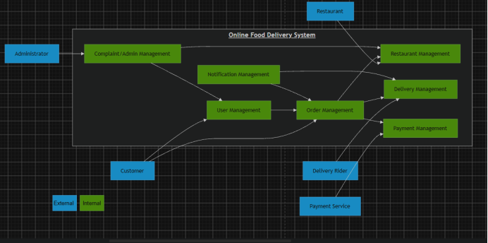

Explanation
- Order Management is the central coordinating module, connecting to Restaurant Management, Delivery Management, and Payment Management.
- Notification Management supports Order Management and Delivery Management by sending status updates.
- User Management handles account-related requests from Customers and feeds into Order Management.
- Complaint/Admin Management gives the Administrator control over User Management and Restaurant Management (e.g approving/removing restaurants, resolving complaints).
- Restaurant Management, Delivery Management, and Payment Management each interface directly with their corresponding external entity (Restaurant, Delivery Rider, Payment Service).

Context Diagram vs. System Diagram
Aspect | Context Diagram | System Diagram
Perspective | External / boundary view | Internal high-level view
System representation | One complete system | Major internal modules
External entities | Shown | Shown where useful for interaction
 |  | context
Internal modules | Not shown | Shown
Main purpose | Define boundary and external interactions | Explain major internal organization
Level of detail | Very high level | More detailed, but still conceptual

Requirement to Diagram Traceability
Requirement | Context Diagram Evidence | System Diagram Evidence
R1 Browse & order | Customer <-> System (Order Request / Login) | User Management -> Order  Management
R2 Online payment | System <-> Payment Service | Order Management -> Payment Management
R3 Restaurant order/status | System <-> Restaurant | Order Management <-> Restaurant  Management
R4 Delivery request/status | System <-> Delivery Rider | Order Management / Notification  Management <-> Delivery  Management
R5 Payment processing | System <-> Payment Service | Payment Management <-> Payment Service
R6 Admin manages users/restaurants/complaints | Administrator <-> System | Complaint/Admin Management <->  User Management, Restaurant  Management

Ambiguities and Assumptions

Ambiguities
- The problem statement does not specify whether Notification Management is a requirement or an implementation choice, it was added as a supporting module for order status updates.
- The scope of "complaints" is not defined , it is unclear whether complaints can be raised by customers, restaurants, or riders, or all three.

Assumptions
- Payment Service is assumed to be a separate external system.
- Restaurants are assumed to have some interface (app/portal) to receive orders and update status, since the requirement states they "receive orders and update order status".
- Administrator is assumed to be a single internal role with access to Complaint/Admin Management, rather than an external organization.

